[LAB SUBMISSION – 4](https://github.com/shrishtinigam/DSA_Lab/tree/main/Lab_4)

# Meher Shrishti Nigam – 20BRS1193

*All the required functions are implemented in the following C code.*

*Output is at the end.*

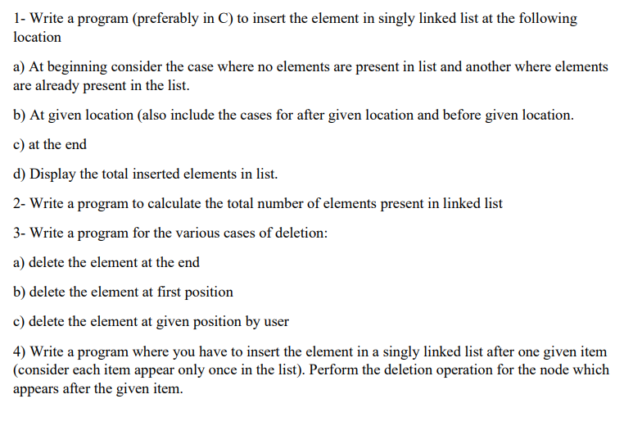

*// SinglyLinkedList.c*

#include <stdio.h>

#include <stdlib.h>

#include <limits.h>

*/*  A singly linked list here is defined by just the "start".*

*"start" is a node pointer that doesn't store any data, just stores the address* *of the first element in the linked list.*

*"len" stores the number of elements in the linked list. This can be easily calculated,* *however it is added to make things easier and for illustration. It can be removed.*

*Functions are written independent of len.*

*Functions provided:*

*insertAtStart*

*insertAtEnd*

*insertAtPosition*

*insertAfterPosition*

*insertBeforePosition*

*insertAfterGivenData*

*display*

*count*

*search*

*deleteAtStart*

*deleteAtEnd*

*deleteAtPosition*

*deleteAfterGivenData*

*\*/*

typedef struct Node{

    int data;

    struct Node * next;

}Node;

typedef struct SinglyLinkedList

{

    Node * start;

    int len;

}SinglyLinkedList;

Node * createNode(int *item*)

{

    Node * temp = (Node *)malloc(sizeof(Node));

    temp->data = *item*;

    temp->next = NULL;

    return temp;

}

SinglyLinkedList * createSinglyLinkedList()

{

    SinglyLinkedList * sll = (SinglyLinkedList *)malloc(sizeof(SinglyLinkedList));

    sll->len = 0;

*/* Creating a start node that will store the location of the first node. It stores null at the time of declaration. */*

    sll->start = (Node *)malloc(sizeof(Node));

    sll->start->data = INT_MIN;

*// Data in the start node is never to be accessed. If INT_MIN is the data displayed, an error has possibly occured*

    sll->start->next = NULL;

    printf("A new singly linked list was created!\n");

    return sll;

}

*/* Insertion */*

*// Inserts an element at the start of a linked list*

void insertAtStart(SinglyLinkedList * *sll*, int *item*)

{

    Node * newnode = createNode(*item*);

    newnode->next = *sll*->start->next;

*sll*->start->next = newnode;

    printf("%d was inserted at the start of the singly linked list!\n", *item*);

*sll*->len++;

}

*// Inserts an element at the end of a linked list*

void insertAtEnd(SinglyLinkedList * *sll*, int *item*)

{

    Node * newnode = createNode(*item*);

    Node * ptr = *sll*->start;

    while(ptr->next != NULL)

        ptr = ptr->next;

    ptr->next = newnode;

    printf("%d was inserted at the end of the singly linked list!\n", *item*);

*sll*->len++;

}

*// Inserts an element at a specified position.*

*// Here, position is determined by usual 1-base counting. If position = 5, item will be the fifth element in the linked list*

void insertAtPosition(SinglyLinkedList * *sll*, int *item*, int *position*)

{

    if(*position* > *sll*->len + 1)

    {

        printf("Invalid Location\n");

        return;

    }

    Node * newnode = createNode(*item*);

    Node * ptr = *sll*->start;

    for(int i = 0; i < (*position* - 1); i++)

        ptr = ptr->next;

    newnode->next = ptr->next;

    ptr->next = newnode;

    printf("%d was inserted at position %d of the singly linked list!\n", *item*, *position*);

*sll*->len++;

}

*// Inserts an element after a specified position.*

*// Here, position is determined by usual 1-base counting. If position = 5, item will be the sixth element in the linked list.*

void insertAfterPosition(SinglyLinkedList * *sll*, int *item*, int *position*)

{

    insertAtPosition(*sll*, *item*, *position* + 1);

}

*// Inserts an element before a specified position.*

*// Here, position is determined by usual 1-base counting. If position = 5, item will be the fourth element in the linked list.*

void insertBeforePosition(SinglyLinkedList * *sll*, int *item*, int *position*)

{

    insertAtPosition(*sll*, *item*, *position* - 1);

}

*// Insert an element after a given data. Example, in 10 20 30 40, enter item = 50 after data = 20, to make it 10 20 50 30 40.*

void insertAfterGivenData(SinglyLinkedList * *sll*, int *item*, int *data*)

{

*/\**

*\*   Another method -*

*\*   int position = search(sll, data);*

*\*   if(position == INT_MIN)*

*\*   {*

*\*      printf("Data doesn't exist\n");*

*\*      return;*

*\*   }*

*\*   insertAtPosition(sll, item, position);*

*\*/*

    if(*sll*->start == NULL)

    {

        printf("Data doesn't exist\n");

        return;

    }

    Node * ptr = *sll*->start;

    while(ptr->data != *data*)

    {

        ptr = ptr->next;

        if(ptr->data != *data* && ptr->next == NULL)

        {

            printf("Data doesn't exist\n");

            return;

        }

    }

    Node * newnode = createNode(*item*);

    newnode->next = ptr->next;

    ptr->next = newnode;

    printf("%d was inserted after %d in the singly linked list!\n", *item*, *data*);

*sll*->len++;

}

*/* Traversal */*

*/* Display function provided for illustrative purposes.*/*

void display(SinglyLinkedList * *sll*)

{

    int count = 0;

*// Printing data*

    Node * ptr = *sll*->start->next; *// Setting pointer to the first element in the singly linked list*

    printf("Start: %d \n", *sll*->start);

    while(ptr != NULL)

    {

        count++;

        printf("%d      ", ptr->data);

        ptr = ptr->next;

    }

*// Printing the location*

    Node * ptr2 = *sll*->start->next;

    printf("\n%d ", *sll*->start->next);

    while(ptr2 != NULL)

    {

        printf("%d ", ptr2->next);

        ptr2 = ptr2->next;

    }

    printf("\nTotal Elements in the Linked List: %d\n\n", count);

}

void count(SinglyLinkedList * *sll*)

{

    int count = 0;

    Node * ptr = *sll*->start->next; *// Setting pointer to the first element in the singly linked list*

    while(ptr != NULL)

    {

        count++;

        ptr = ptr->next;

    }

    printf("\nTotal Elements in the Linked List: %d", count);

*// Comparing count to len (count stored in singly linked list data structure)*

    if(count == *sll*->len)

        printf(" which is equal to len.\n");

    else

        printf(" which is not equal to len.\n");

}

*// Returns the 1-base position of the item.*

int search(SinglyLinkedList * *sll*, int *item*)

{

    int count = 1;

    Node * ptr = *sll*->start->next;

    while(ptr->data != *item*)

    {

        ptr = ptr->next;

        count++;

        if(ptr->data != *item* && ptr->next == NULL)

        {

            printf("%d not found in the linked list.\n", *item*);

            return INT_MIN;

        }

    }

    printf("%d found at %d position in the singly linked list.\n", *item*, count);

    return count;

}

*/* Deletion */*

*// Deletion at start*

int deleteAtStart(SinglyLinkedList * *sll*)

{

    if(*sll*->start == NULL)

    {

        printf("Singly Linked List is empty, nothing to delete\n");

        return INT_MIN;

    }

    Node * ptr = *sll*->start->next;

*sll*->start->next = ptr->next;

    int data = ptr->data;

    free(ptr);

    printf("%d was deleted from the start of the singly linked list.\n", data);

*sll*->len--;

    return data;

}

*// Deletion at end*

int deleteAtEnd(SinglyLinkedList * *sll*)

{

    if(*sll*->start == NULL)

    {

        printf("Singly Linked List is empty, nothing to delete\n");

        return INT_MIN;

    }

    Node * ptr = *sll*->start;

    while(ptr->next->next != NULL)

       ptr = ptr->next;

    Node * ptr2 = ptr->next;

    int data = ptr2->data;

    free(ptr2);

    ptr->next = NULL;

    printf("%d was deleted from the end of the singly linked list.\n", data);

*sll*->len--;

    return data;

}

*// Deletion of an element at a particular position*

*// Here, position is determined by usual 1-base counting.*

int deleteAtPosition(SinglyLinkedList * *sll*, int *position*)

{

    if(*sll*->start == NULL)

    {

        printf("Singly Linked List is empty, nothing to delete\n");

        return INT_MIN;

    }

    if(*position* > *sll*->len)

    {

        printf("Invalid Location\n");

        return INT_MIN;

    }

    Node * ptr = *sll*->start;

    for(int i = 0; i < (*position* - 1); i++)

        ptr = ptr->next;

    Node * ptr2 = ptr->next;

    ptr->next = ptr2->next;

    int data = ptr2->data;

    free(ptr2);

*sll*->len--;

    printf("%d was deleted from %d position of the singly linked list.\n", data, *position*);

    return data;

}

*// Delete the element present after a given data*

int deleteAfterGivenData(SinglyLinkedList * *sll*, int *data*)

{

    if(*sll*->start == NULL)

    {

        printf("Singly Linked List is empty, nothing to delete\n");

        return INT_MIN;

    }

    Node * ptr = *sll*->start;

    while(ptr->data != *data*)

    {

        ptr = ptr->next;

        if(ptr->data != *data* && ptr->next == NULL)

        {

            printf("Data doesn't exist\n");

            return INT_MIN;

        }

    }

    if(ptr->next == NULL)

    {

        printf("This is the last element, nothing to delete after this.\n");

        return INT_MIN;

    }

    Node * ptr2 = ptr->next;

    ptr->next = ptr2->next;

    int val = ptr2->data;

    free(ptr2);

    printf("The element after %d was %d, and it has been deleted from the singly linked list.\n", *data*, val);

*sll*->len--;

    return val;

}

int main()

{

    SinglyLinkedList * sll = createSinglyLinkedList();

*// Insertion At Start*

    insertAtStart(sll, 10); *// Singly Linked List is empty initially*

    display(sll);

    insertAtStart(sll, 20); *// Singly Linked List has one element initially*

    display(sll);

    insertAtStart(sll, 30);

    display(sll);

*// Insertion at the end*

    insertAtEnd(sll, 40);

    display(sll);

    insertAtEnd(sll, 50);

    display(sll);

    insertAtEnd(sll, 60);

    display(sll);

*// Insertion at position*

    insertAtPosition(sll, 70, 3);

    display(sll);

    insertBeforePosition(sll, 80, 2);

    display(sll);

    insertAfterPosition(sll, 90, 6);

    display(sll);

*// Insertion after given data*

    insertAfterGivenData(sll, 100, 60);

    display(sll);

    insertAfterGivenData(sll, 110, 90);

    display(sll);

    insertAfterGivenData(sll, 120, 25); *// 25 is not present in the sll*

    display(sll);

*// Delete at start*

    deleteAtStart(sll);

    display(sll);

    deleteAtStart(sll);

    display(sll);

*// Delete at end*

    deleteAtEnd(sll);

    display(sll);

    deleteAtEnd(sll);

    display(sll);

*// Inserting a few more values*

    insertAtEnd(sll, 40);

    insertAtEnd(sll, 50);

    insertAtEnd(sll, 60);

*// Delete at position*

    deleteAtPosition(sll, 5);

    display(sll);

    deleteAtPosition(sll, 1);

    display(sll);

    deleteAtPosition(sll, 8);

    display(sll);

*// Delete after given data*

    deleteAfterGivenData(sll, 120);

    display(sll);

    deleteAfterGivenData(sll, 50);

    display(sll);

    deleteAfterGivenData(sll, 50);

    display(sll);

    deleteAfterGivenData(sll, 50);

    display(sll);

*// Count*

    count(sll);

*// Search*

    search(sll, 50);

    search(sll, 45);

}

